**Raspberry Pi 5 Pinouts**

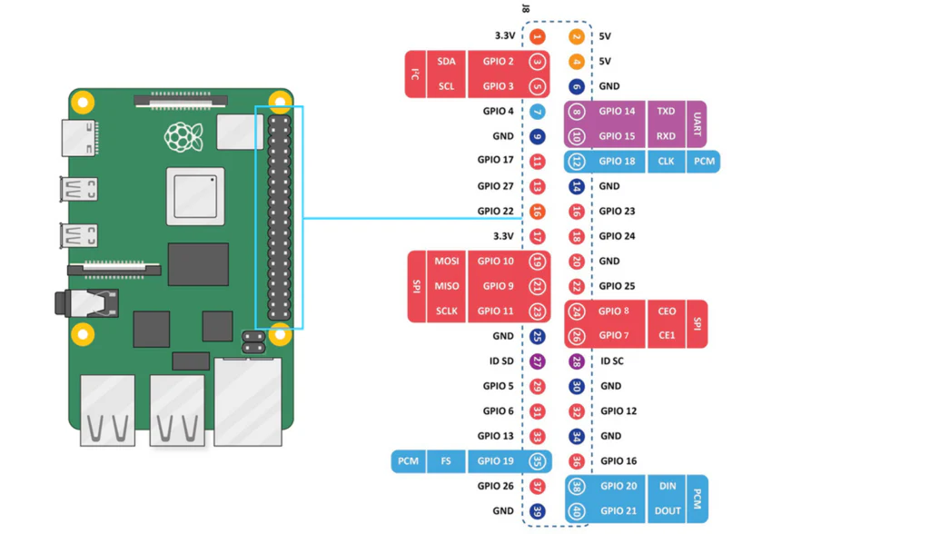

**Understanding the Raspberry Pi 5 GPIO and Peripheral Interfaces**

The Raspberry Pi 5 introduces several enhancements and refinements to its GPIO (General Purpose Input/Output) header and peripheral interfaces, making it an even more versatile platform for developers, hobbyists, and professionals alike. This guide provides a detailed breakdown of the key headers, GPIO capabilities, and common use cases to help users better understand and utilize these features.

---

## **Key Headers and Their Functions**

The Raspberry Pi 5 board includes several important headers, each serving a distinct function:

### **1. J8 GPIO Header**

The J8 GPIO header consists of the standard 40-pin layout found on previous Raspberry Pi models. This allows for backward compatibility with add-ons and HATs (Hardware Attached on Top) designed for earlier Raspberry Pi boards.

### **2. J14 PoE (Power over Ethernet)**

The J14 header provides a Power over Ethernet (PoE) connection, enabling the Raspberry Pi 5 to receive both power and data over a single Ethernet cable. This is particularly useful in industrial applications, remote deployments, and network-based monitoring systems where a dedicated power supply may not be feasible.

### **3. J2 Power Switch**

Though not officially confirmed, the J2 header may be associated with the Real-Time Clock (RTC) battery, which helps maintain the system clock when power is disconnected. This is beneficial for time-sensitive applications, such as data logging or scheduling tasks.

### **4. J7 Composite Video Output**

Unlike earlier Raspberry Pi models that combined composite video output with the audio jack, the J7 header now provides a dedicated composite video output. This can be useful for legacy display systems, low-cost video playback devices, or educational projects requiring analog video.

### **5. J17 Fan Header**

The J17 fan header allows for Pulse Width Modulation (PWM) control of an active cooling fan, providing better temperature management. It also supports fan speed feedback, enabling precise thermal control—ideal for performance-heavy applications such as AI processing, gaming, or video encoding.

---

## **RP1 GPIO Bank (IO_BANK0) Capabilities**

The RP1 chip in the Raspberry Pi 5 enhances GPIO functionality by supporting multiple peripheral interfaces. These include:

- **5 UART (Universal Asynchronous Receiver-Transmitter) interfaces** – For serial communication, commonly used in embedded systems and debugging.

- **6 SPI (Serial Peripheral Interface) interfaces** – Useful for high-speed communication with sensors, displays, and other peripherals.

- **4 I2C (Inter-Integrated Circuit) interfaces** – Widely used for connecting sensors and other low-speed peripherals.

- **2 I2S (Inter-IC Sound) interfaces** – For digital audio communication, including Clock Producer and Clock Consumer instances.

- **Registered IO (RIO) interface** – Enables high-speed, low-latency digital input/output operations.

- **24-bit DPI (Display Parallel Interface) output** – Allows for direct connection to LCD screens without HDMI.

- **4-channel PWM output** – Essential for motor control, LED dimming, and other variable-output applications.

- **Stereo PWM audio output (AUDIO_OUT)** – Supports high-quality audio output.

- **General-purpose clock input and output (GPCLK)** – Useful for synchronization with external systems.

- **eMMC/SDIO bus with a 4-bit interface** – Enables faster and more reliable data storage access.

- **Interrupt generation from pin level or edge transitions** – Useful for event-driven programming in automation and sensor applications.

Use Cases

- **Home Automation:** GPIO interfaces with I2C sensors for temperature and humidity control, SPI-connected LED matrices for notifications, and PWM for controlling lighting intensity.

- **Robotics:** PWM control for servos and motors, SPI communication with motor drivers, and GPIO input for obstacle sensors.

- **IoT Devices:** UART for communicating with external microcontrollers, I2C for integrating with environmental sensors, and Wi-Fi modules controlled via GPIO.

- **Audio Processing:** I2S for high-fidelity audio input and output, useful in music synthesizers and recording applications.

---

## **GPIO Pinout and Considerations**

Like previous Raspberry Pi models, the GPIO pins on the Raspberry Pi 5 can be configured for multiple functions. Each GPIO can have only one function selected at a time. Additionally, each peripheral input (e.g., I2C3_SCL) should only be assigned to one GPIO at a time to avoid conflicts. If the same peripheral input is connected to multiple GPIOs, the peripheral interprets the logical OR of those inputs.

A common question among Raspberry Pi users is how the GPIO pin numbering corresponds to the physical board layout. It's important to note that the printed GPIO numbers on the board do not follow sequential numerical order. For example:

- **GPIO 0 and 1** (printed on the board) actually correspond to **pins 27 and 28**.

- The Raspberry Pi provides an onboard pinout reference. To access this, open a command terminal and type:

```sh

pinout

```

Then press **Enter** to display a graphical representation of the pinout for the Raspberry Pi model in use.

### **Power and Ground Pins**

The Raspberry Pi GPIO header includes dedicated power and ground pins:

- **5V Power Pins:** Pin numbers **2** and **4** provide a direct 5V power source.

- **Ground Pins:** The following pins serve as ground (GND) connections:

- **Pin 6, 9, 14, 20, 25, 30, 34, 39**

The Raspberry Pi 5 offers enhanced GPIO and peripheral connectivity, making it a powerful platform for a wide range of applications. Whether you're working on robotics, home automation, IoT, or multimedia projects, understanding the capabilities of the GPIO and its associated headers will help maximize the potential of your Raspberry Pi. By leveraging the built-in pinout command and carefully selecting the appropriate GPIO functions, users can create efficient and innovative solutions tailored to their needs.